AI ASSISTED CODING
LAB-12.5
P. SANDEEP 2303A510G1

Batch-30
Task Description #1 (Sorting – Merge Sort Implementation) • Task: Use AI to generate a Python program that implements the Merge Sort algorithm.
• Instructions: o Prompt AI to create a function merge_sort(arr) that sorts a list in ascending order.
o Ask AI to include time complexity and space complexity in the function docstring. o Verify the generated code with test cases.
- Expected Output: o A functional Python script implementing Merge Sort with proper documentation.
PROMPT:
#Write a python code to that implements the merge sort algorithm to sort a list of integers in ascending order.Include time complexity and space complexity analysis in the comments and docstrings
CODE and OUTPUT:
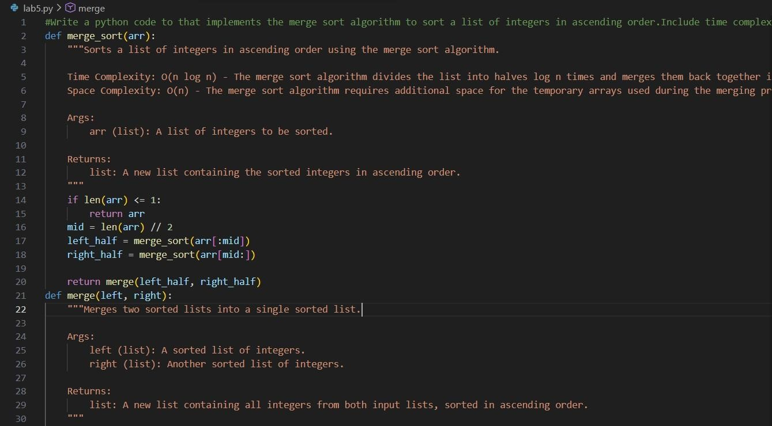
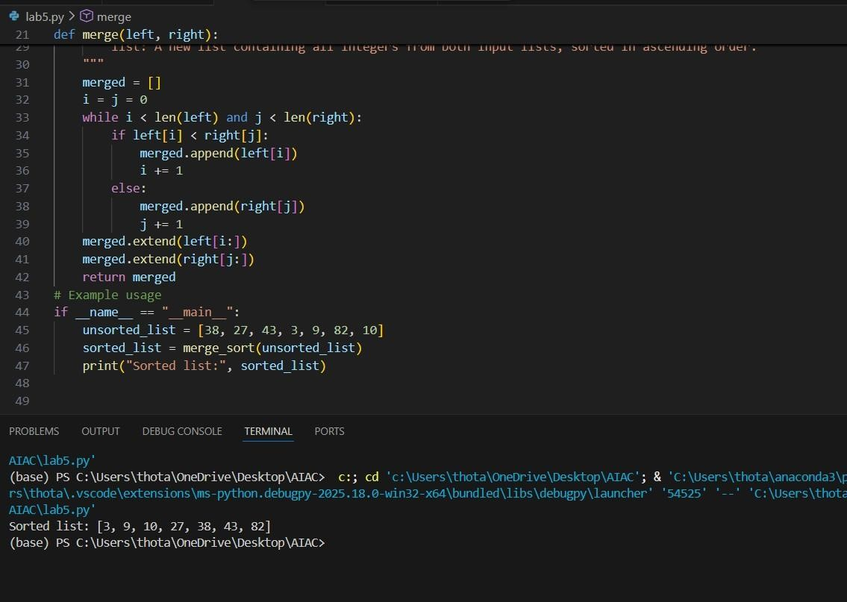
Task Description #2 (Searching – Binary Search with AI
Optimization)
- Task: Use AI to create a binary search function that finds a target element in a sorted list.
- Instructions:
- Prompt AI to create a function binary_search(arr, target) returning the index of the target or -1 if not found.
- Include docstrings explaining best, average, and worst-case complexities. o Test with various inputs.
• Expected Output: o Python code implementing binary search with AI-
generated comments and docstrings PROMPT:
#Write a python code to create a function binary_search(arr,target) returning the index of the target or -1 if notfound.o Include docstrings explaining best, average, and worst-case complexities.o Test with various inputs.
CODE AND OUTPUT:
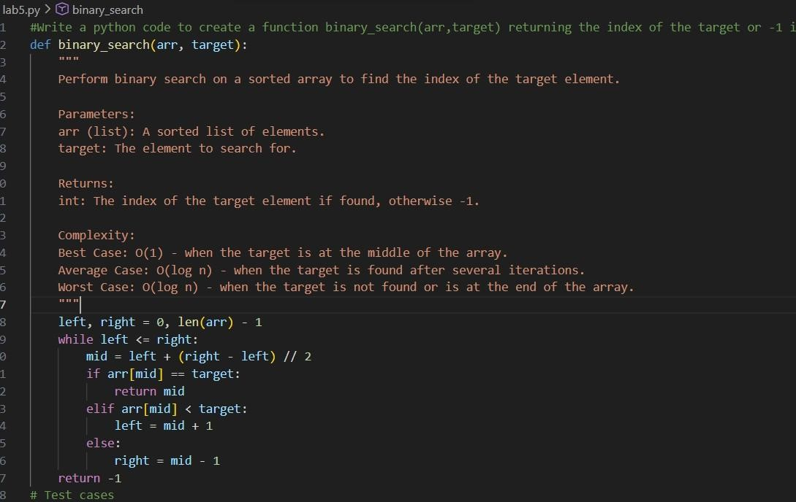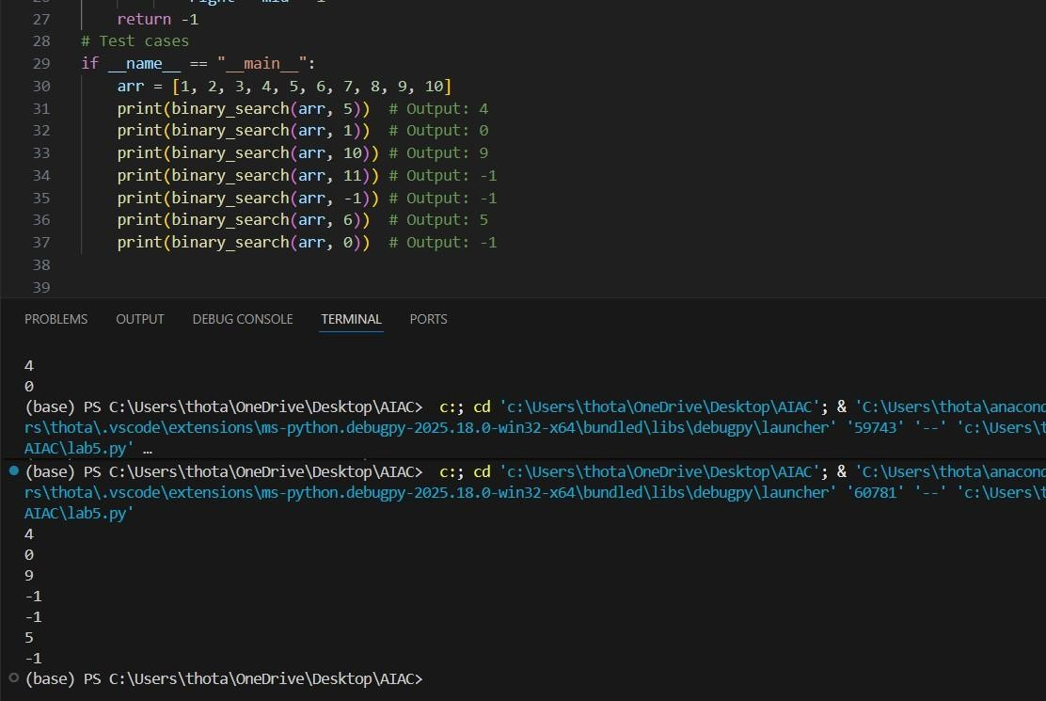
Task Description #3: Smart Healthcare Appointment Scheduling System
A healthcare platform maintains appointment records containing appointment ID, patient name, doctor name, appointment time, and consultation fee. The system needs to:
- Search appointments using appointment ID.
- Sort appointments based on time or consultation fee.
Student Task
- Use AI to recommend suitable searching and sorting algorithms.
- Justify the selected algorithms.
- Implement the algorithms in Python.
PROMPT:
#write python code to create A healthcare platform maintains appointment records containing appointment ID, patient name, doctor name, appointment time, and consultation fee. The system needs to:1. Search appointments using appointment ID. 2. Sort appointments based on time or consultation fee.Use suitable searching and sorting algorithms

CODE AND OUTPUT:
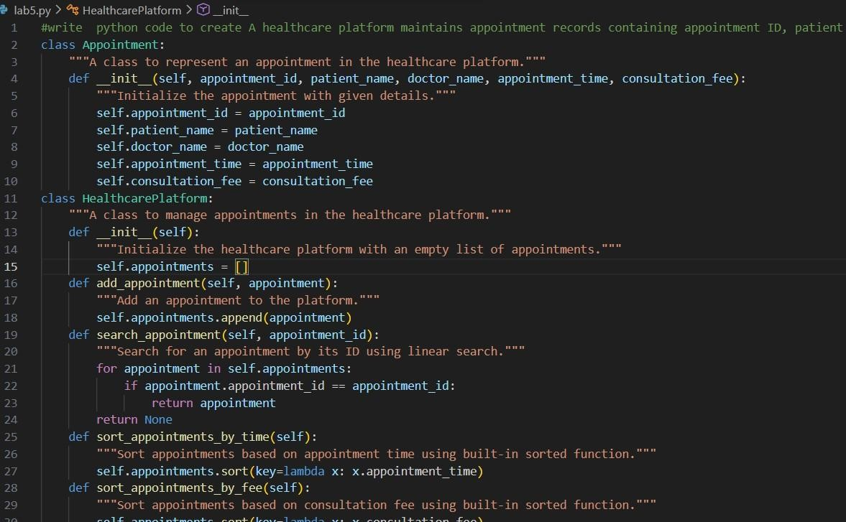
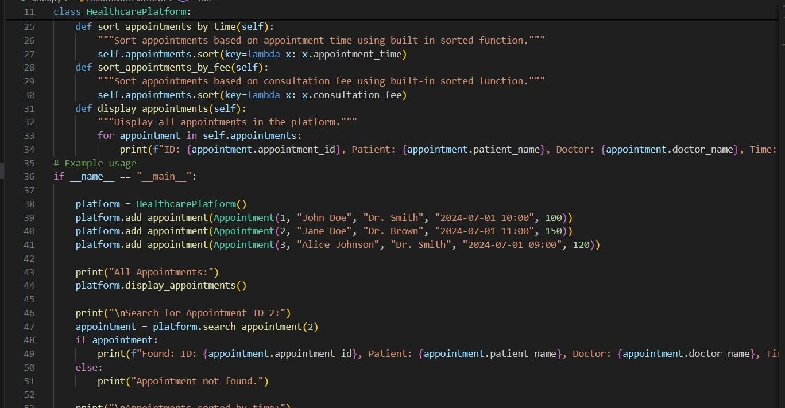

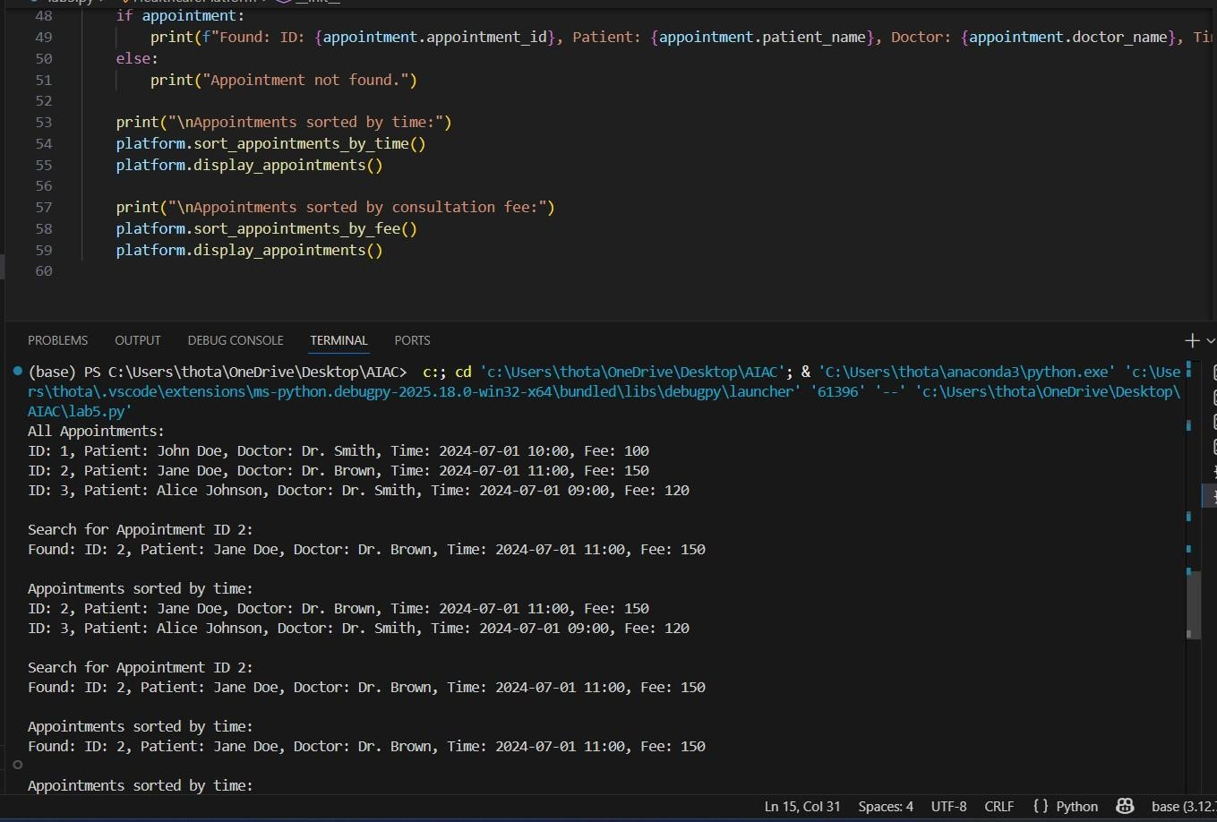
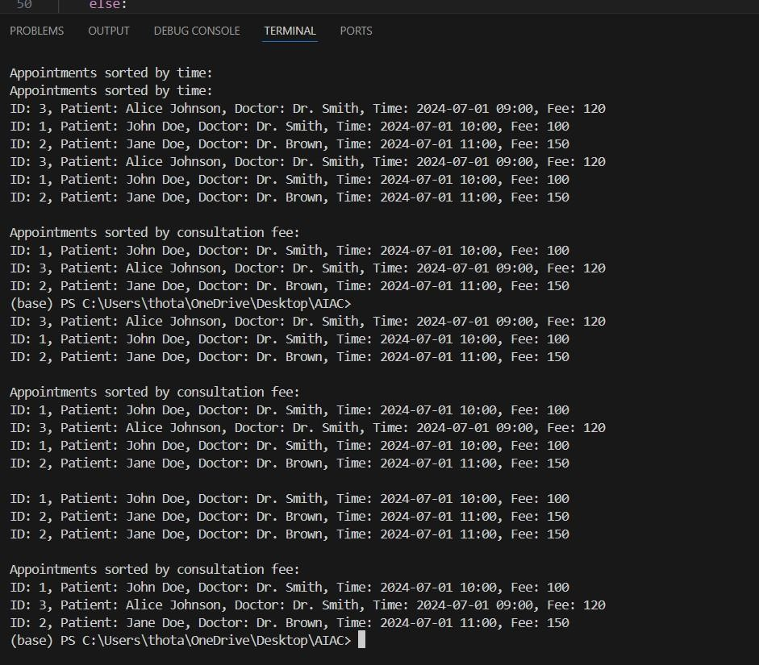
Task Description #4: Railway Ticket Reservation System
Scenario
A railway reservation system stores booking details such as ticket ID, passenger name, train number, seat number, and travel date. The system must:
- Search tickets using ticket ID.
- Sort bookings based on travel date or seat number.
Student Task
- Identify efficient algorithms using AI assistance.
- Justify the algorithm choices.
- Implement searching and sorting in Python.

PROMPT:
#write a python program to create a railway reservation sytstem stores booking details such as passenger name,ticket id,train number,seat number,and travel date.you have to search the tickets using ticket id and sort bookings based on travel date or set number. identify the best algorithmsfor searching and sortingand implement them in your program CODE AND OUTPUT:
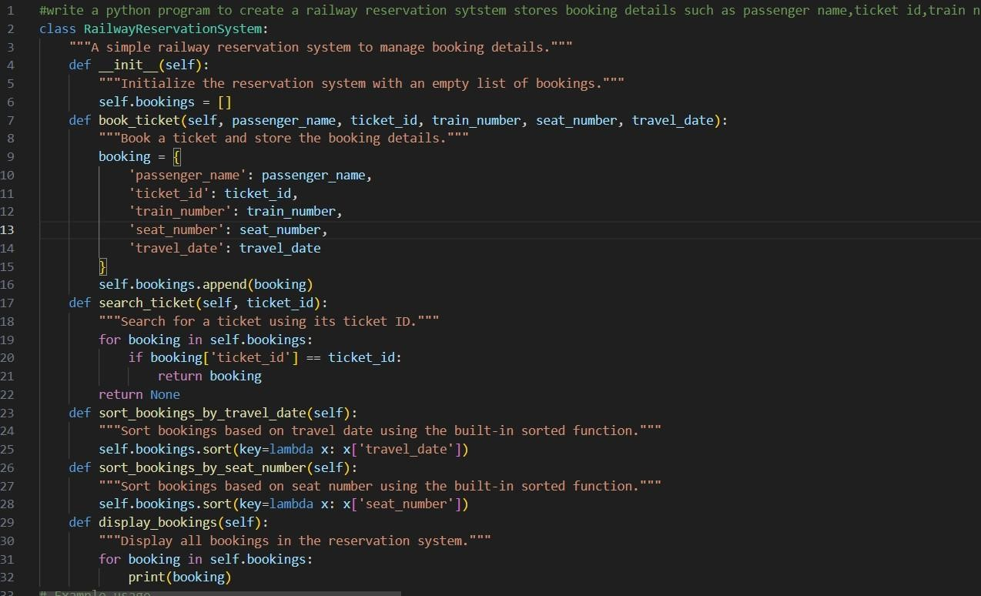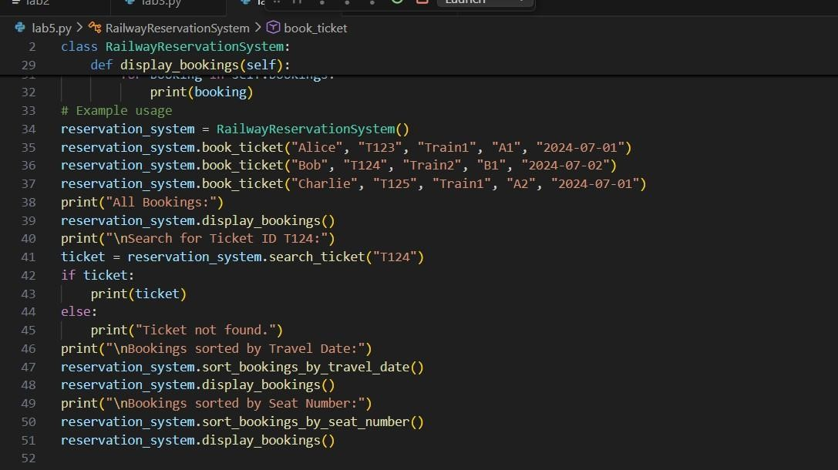
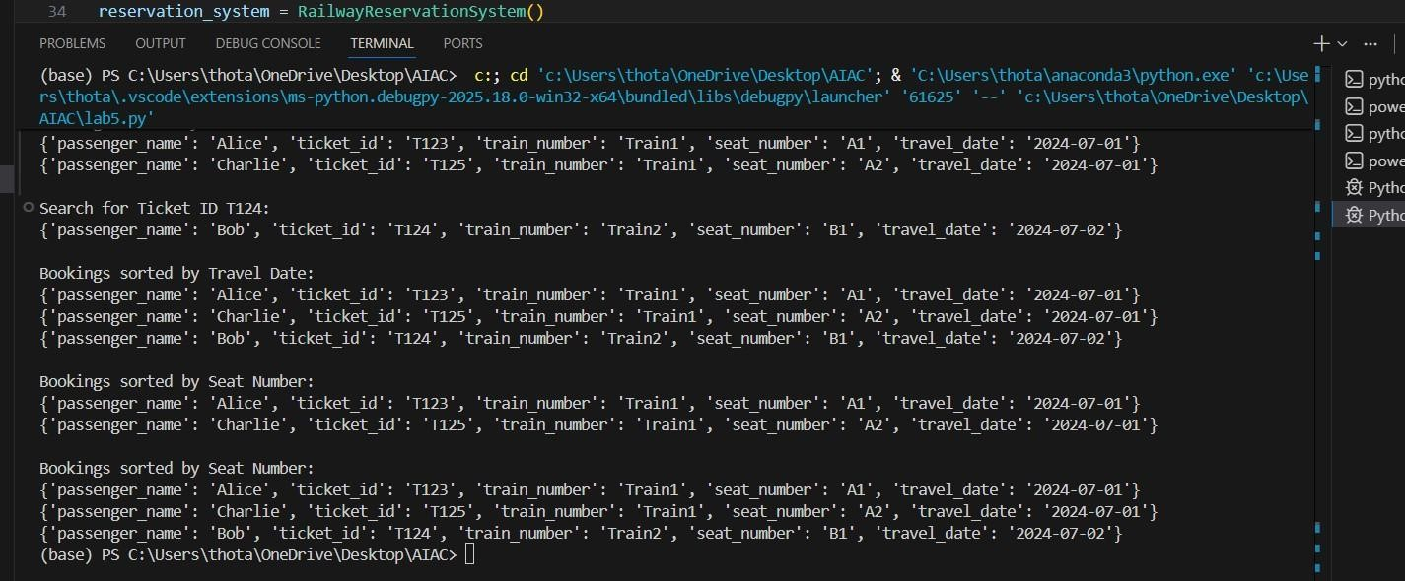
Task Description #5: Smart Hostel Room Allocation System A hostel management system stores student room allocation details including student ID, room number, floor, and allocation date. The system needs to:
- Search allocation details using student ID.
- Sort records based on room number or allocation date.
Student Task
- Use AI to suggest optimized algorithms.
- Justify the selections.
- Implement the solution in Python.
PROMPT:
#write a python program to create a hostel management system it stores student room allocation details including student id,room number,floor,and allocation date. you have to search allocation details using student id and sort records based on room number or allocation date.you have to sugest optimized algorthms for searching and sorting the records CODE AND OUTPUT:
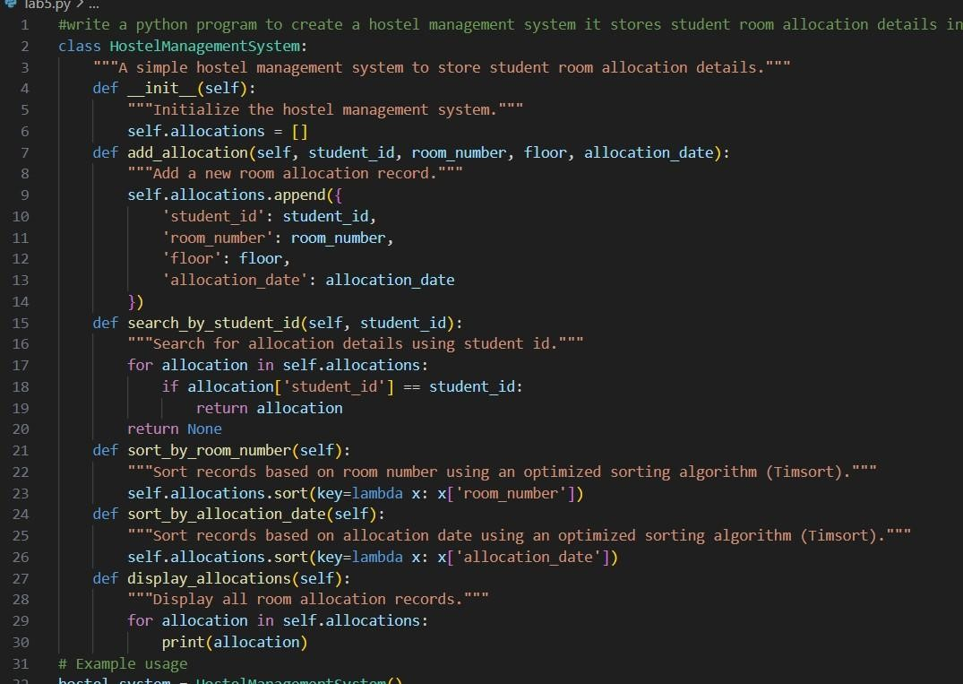
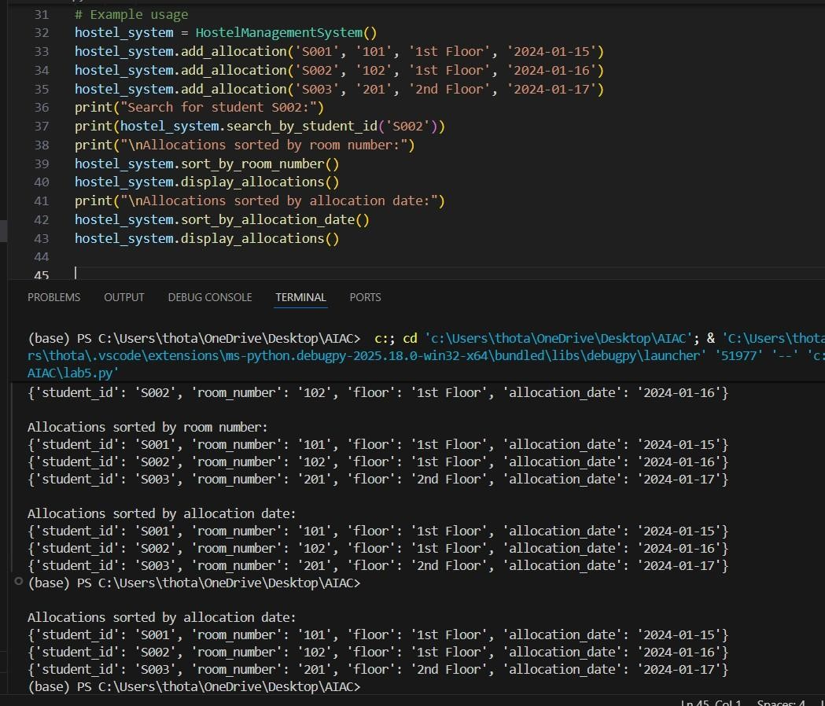
Task Description #6: Online Movie Streaming Platform
A streaming service maintains movie records with movie ID, title, genre, rating, and release year. The platform needs to:
- Search movies by movie ID.
- Sort movies based on rating or release year.
Student Task
- Recommend searching and sorting algorithms using AI.
- Justify the chosen algorithms.
- Implement Python functions.
PROMPT:
#write a python program to create a streaming service maintains movie records with movie id,title,genre,rating,and release year. you have to search movies by movie id and sort movies based on rating or release year. you have to recommend searching and sorting algorithms for
this application and justify your choices with comments and docstrings CODE AND OUTPUT:
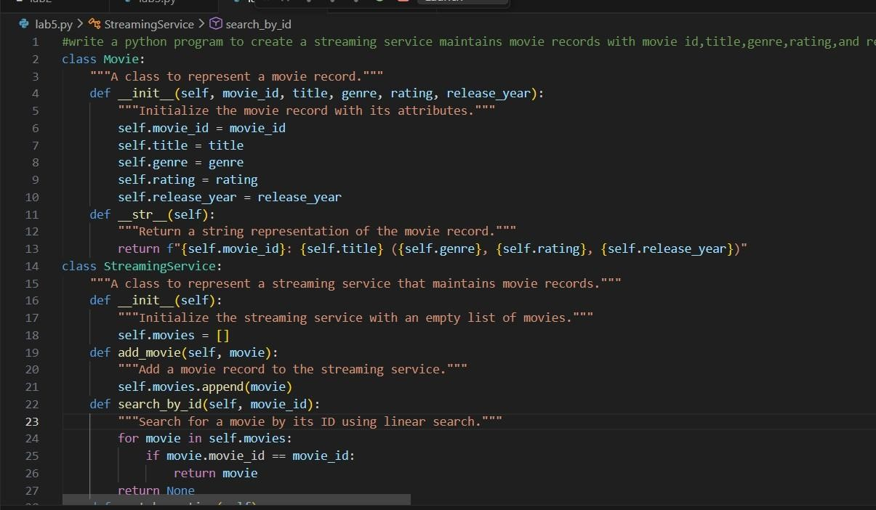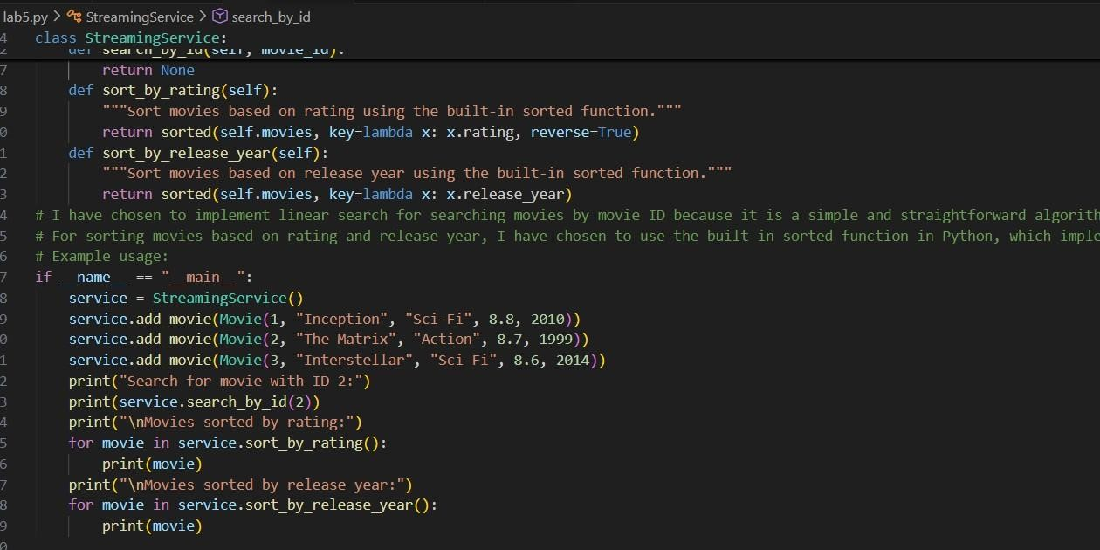
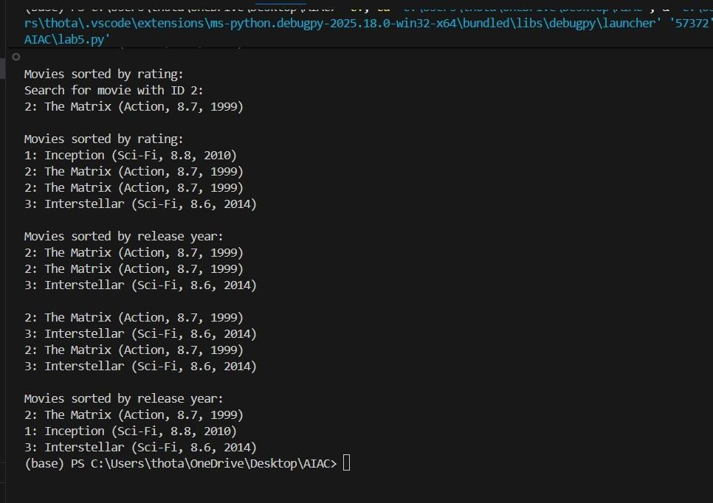
Task Description #7: Smart Agriculture Crop Monitoring System An agriculture monitoring system stores crop data with crop ID, crop name, soil moisture level, temperature, and yield estimate. Farmers need to:
- Search crop details using crop ID.
- Sort crops based on moisture level or yield estimate.
Student Task
- Use AI-assisted reasoning to select algorithms.
- Justify algorithm suitability.
- Implement searching and sorting in Python.
PROMPT:
#write a python program to create an agriculture monitoring system it stores crop data with crop id,crop name,soil moisture level,temperature,and yeild estimate. you have to search crop details using crop id and sort crops based on moisture level or yield estimate .you have to select reasoning algorithm and jusity alorithm and implement searching and sorting CODE AND OUTPUT:
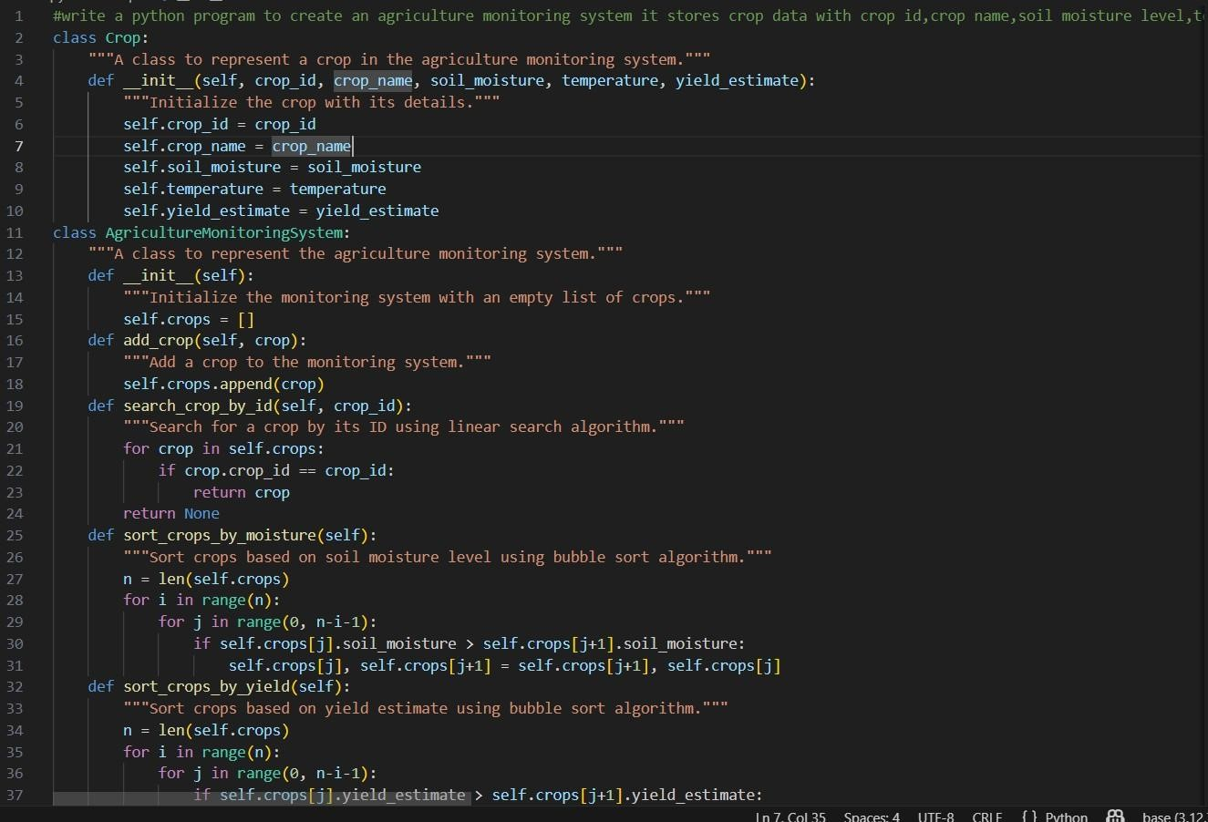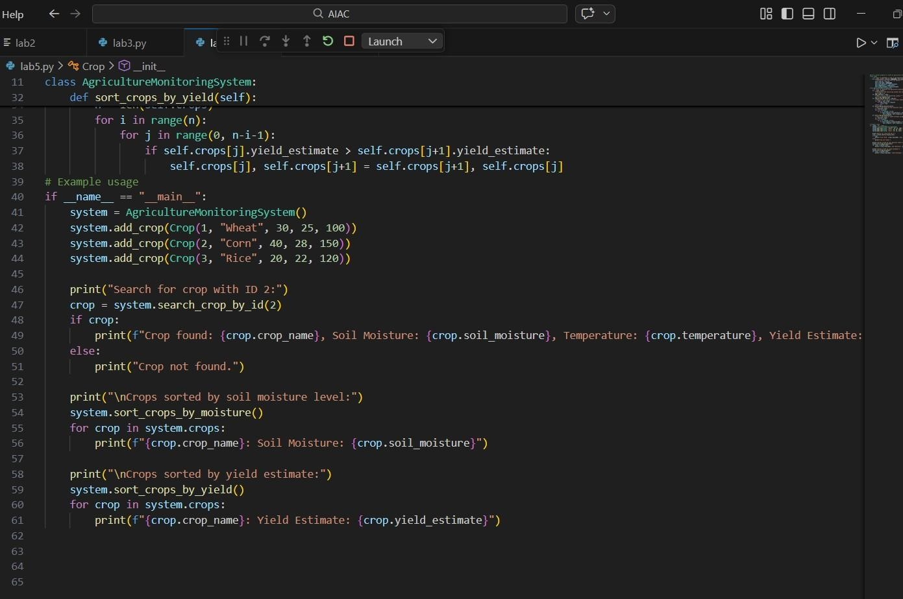
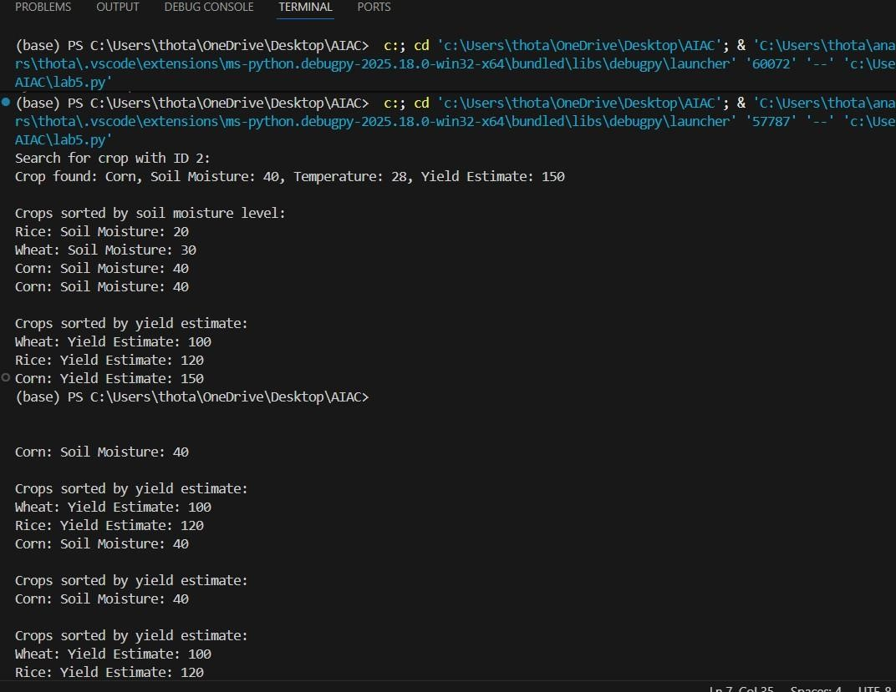
Task Description #8: Airport Flight Management System An airport system stores flight information including flight ID, airline name, departure time, arrival time, and status. The system must:
- Search flight details using flight ID.
- Sort flights based on departure time or arrival time.
Student Task
- Use AI to recommend algorithms.
- Justify the algorithm selection.
- Implement searching and sorting logic in Python PROMPT:
#write a python program to create an airport system store flight information including flight id,airline name,departure time,arrival time,and status. you have to search flight details using flight id and sort bsed on departure time or arrival time..you have to recommend algorithms and justify the algorithm and implement searching and sorting algorithms with comments CODE AND OUTPUT:

